Notes for taking public transportations in Hong Kong
- If you plan to take public transportations such as MTR Railway, Bus or Minibus, you are strongly advised to purchase an Octopus Card – an electronic card which you can deposit money and make payments in most public transportations, convenience stores and supermarkets.
- You can purchase an octopus card in any MTR station. For more information, please visit http://www.octopus.com.hk/home/en/index.html.
- You can easily wave a taxi in Hong Kong at your hotel or just anywhere around Hong Kong, as long as they are vacant. Most taxi drivers in Hong Kong speak English. They only accept cash. Other forms of payment such as Octopus Card or credit cards are not accepted
- If you are taking a Minibus, remember to tell the driver where you want to drop off. Some drivers may not be proficient in English, so seek other passengers to help you in case you need assistance! (Most Hong Kong people are friendly and will be happy to help out!)
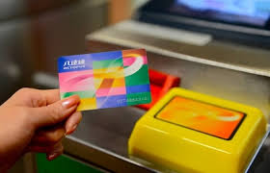 Octopus Card
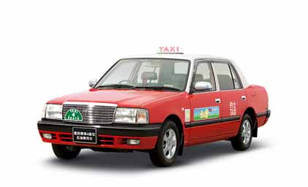Taxi

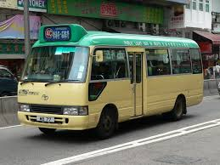 Minibus

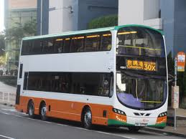 Bus

Directions to Li Ka Shing Faculty of Medicine

- By Taxi Directly to the Faculty
- By MTR: Drop off at HKU Station and leave at exit A2. Take any bus (4, 4X, 90B, 30X, 970, 970X) or Minibus with green top (Number 8, 28) and part at Queen Mary Hospital.
Directions from Queen Mary Hospital to HKU Li Ka Shing Faculty of Medicine
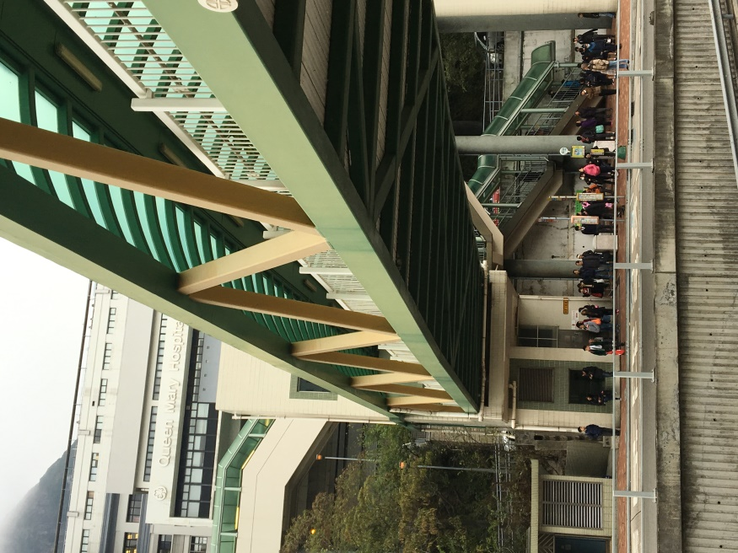Drop off at bus stop outside Queen Mary Hospital at Pokfulam Road 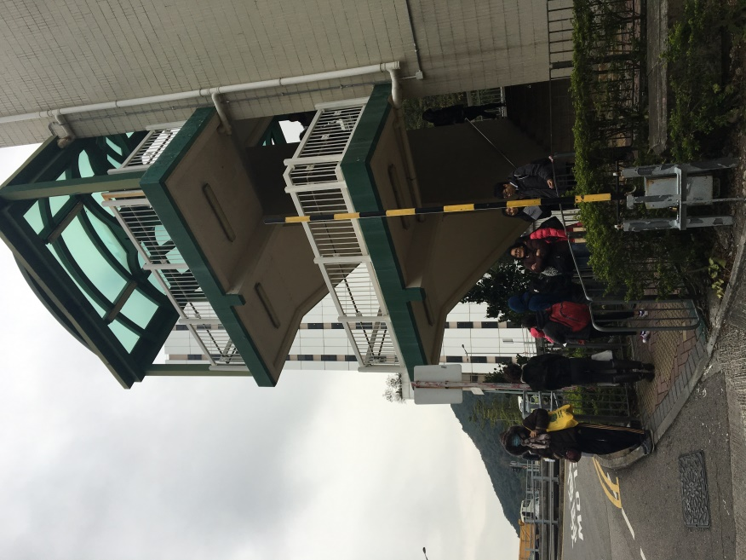 Walk across the bridge and you will reach Sassoon Road
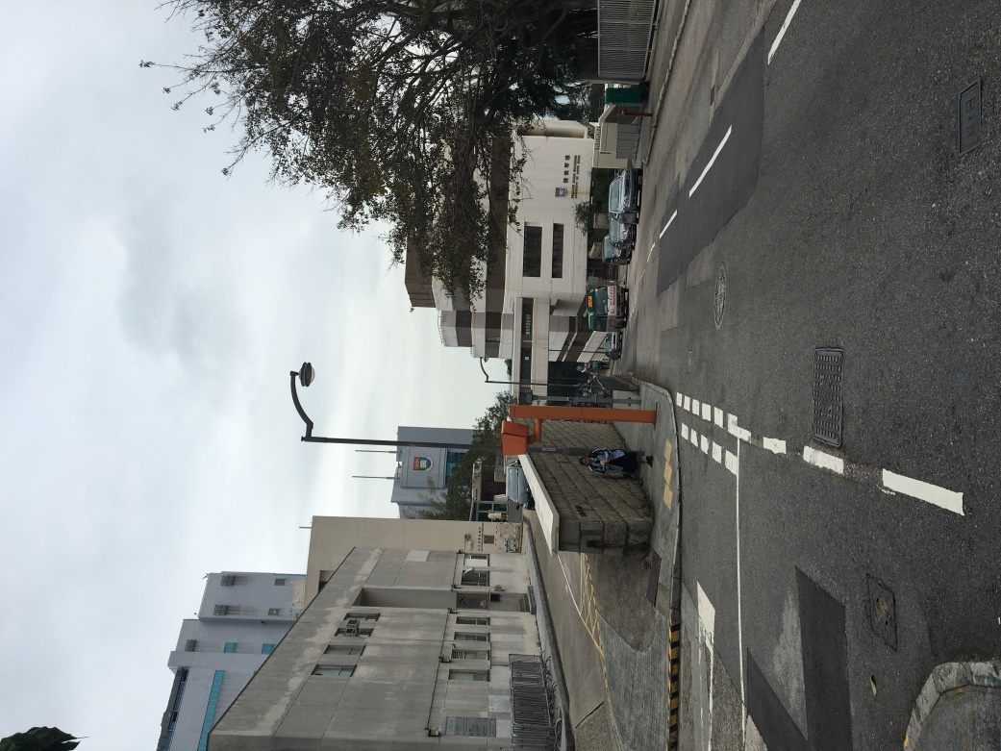 Continue walking downhill
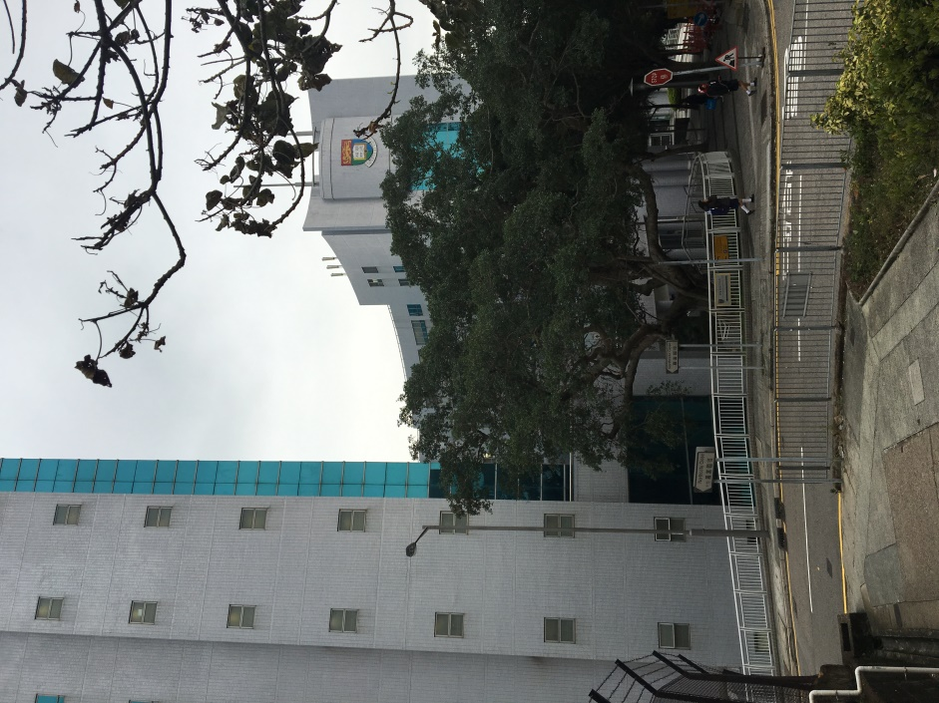
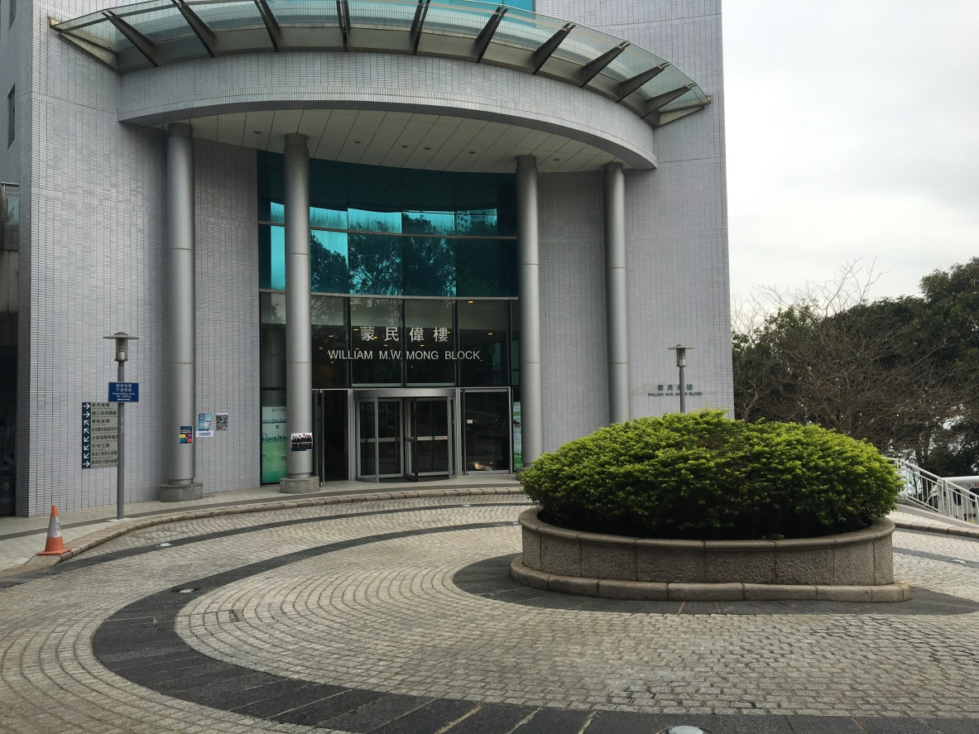
You will reach Li Ka Shing Faculty of Medicine William MW Mong Block in approximately 3minutes.
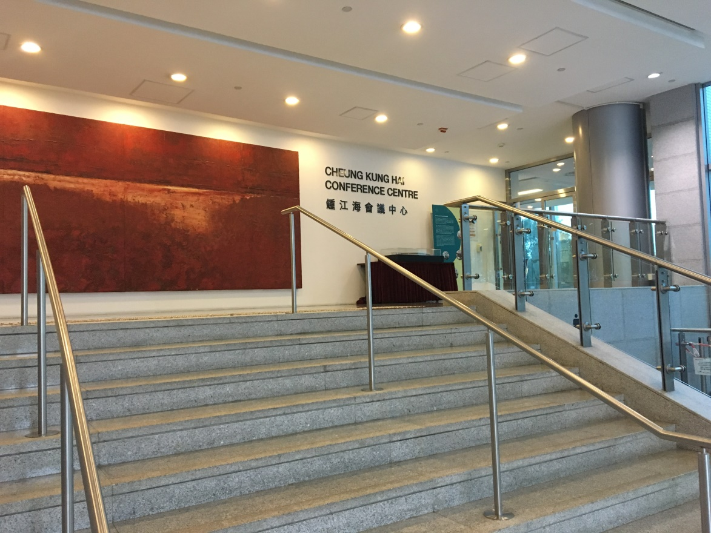
You will see Cheung Kung Hai Conference Centre immediately as you enter William MW Mong Block.
See you soon!

